Guidelines for Assignments
(Make sure you follow the below guidelines for getting good scores in your assignments)

- Please make sure your homework document will have the name
CS547_student_id_HW#_studentname
- Include the script and the screenshots of the output separately.
Example :
Script :
Begin
Dbms_output.put_line(‘Welcome to Fall Semester 2013’);
End;
Screenshot :
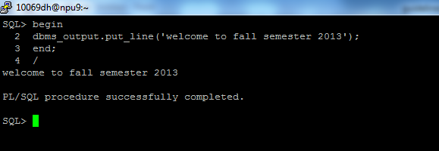
- Do not forget to include your student id in your screenshot.
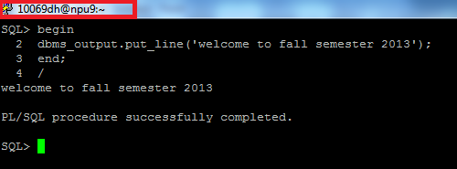
- In case, you are using other tools like Toad or SQL Developer, make sure you always display the sysdate in your output , as there is no way to include your username
Example
For the above script, you can write
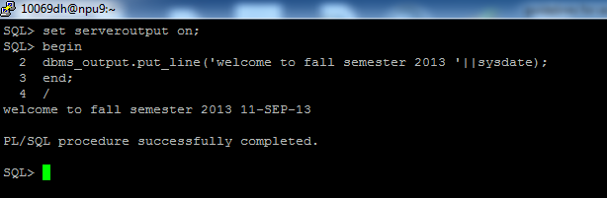

If you are displaying the table output, you can select sysdate as one of the column.
Example
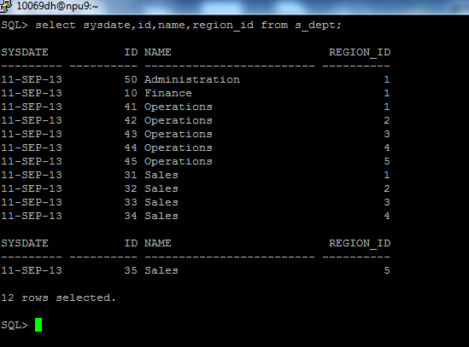
‘
- Deadlines for assignment submission will be strictly followed. Grace period will not be entertained unless approved by the professor.

Note: Assignments which do not fulfill the above guidelines will be deemed incomplete and will be graded accordingly.

Plagiarism will not be tolerated; if detected, assignment will be graded zero.

